Assignment 2

21AIE111

Data Structure and Algorithms – SEM-II

Professor – Dr. Sachin Sir

Submitted By: Vikhyat Bansal [CB.EN.U4AIE21076]



1. Write a java code to create a singly linked list for the sentence “I am writing java code”. Each node will contain the words. Display the value of each nodes.

CODE:

*public* *class* Q1 {

    Node head; // *'head' of the linked list*

    // *node in the Linked list is a class*

*static* *class* Node{

    String data;

    Node next;

    //*constructor is used to create a new Node and Next is by default is initialized as null*

*Node*(String d){

          data = d;

          next = null;

    } //*end of constructor*

    } //*end of static class node*

*public* void *DisplayList*() {

        Node node = head;

*while*(node!=null) {

              System.*out*.*println*("Value at each node: "+node.*data*+" ");

              node = node.*next*;

        }

        }//*end of DisplayList function*

        //*main method*

*public* *static* void *main*(String[] args) {

    Q1 LList = *new* *Q1*(); // *create an empty Linked list*

    // *create 5 nodes*

    LList.*head* = *new* *Node*("I");

    Node two = *new* *Node*("am");

    Node three = *new* *Node*("writing");

    Node four = *new* *Node*("java");

    Node five = *new* *Node*("code");

    //*five nodes allocated dynamically*

    //*link first 'head' node with node 'two'*

    LList.*head*.*next* = two;

    //*link node 'two' to node 'three'*

    two.*next* = three;

    //*link node 'three' to node 'four'*

    three.*next* = four;

    //*link node 'four' to node 'five'*

    four.*next* = five;

    // *display value at each node*

    LList.*DisplayList*(); // *Traverse the list*

    }//*end of main method*

    } //*end of class Q1*

OUTPUT:

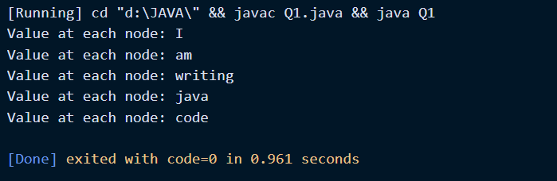

Explanation:

* As it is known that a single linked list contains head, nodes and a tail. We will start by creating a head of linked list, then we will create a class for Node with datatype string.
* Node next will determine the number of nodes being created.
* We will display our linked list using DisplayList() where a while condition is set to see the values of each node and that condition will also check whether empty or not.
* 2. Write a java code to display the value of each node in reverse order (use the linked list created in Q1).

CODE:

*public* *class* Q2 {

    Node head; // *'head' of the linked list*

    // *node in the Linked list is a class*

*static* *class* Node{

    String data;

    Node next;

    //*constructor is used to create a new Node and Next is by default is initialized as null*

*Node*(String string){

          data = string;

          next = null;

    } //*end of constructor*

    } //*end of static class node*

*public* void *DisplayList*() {

        Node node = head;

// *A tempNode to hold the value in node temporarily.*

Node tempNode = *new* *Node*("random string");

/\*

*While node is not null and the data in node is not same as the data in* *tempNode, keep looping.*

\*/

*while*(node != null && !node.*data*.*equals*(tempNode.*data*)){

// *If next node is same as tempNode then print the value in node.*

*if*(node.*next* == tempNode){

tempNode = node;

System.*out*.*print*(tempNode.*data*+" ");

node = head;

/\* *If next node is null then clone node to tempNode and also print the* *value.*

*Node is saved to tempNode so in the next iteration the program can check* *if it reached the last value*

*and print the value just before it.*

*This is possible because tempNode always holds the last value.*

\*/

} *else* *if*(node.*next* == null){

tempNode = node;

System.*out*.*print*(tempNode.*data*+" ");

node = head;

}

node = node.*next*;

}

// *Finally, if head is not null print the value in it.*

*if*(head != null){

System.*out*.*println*(head.*data*);

}

    }

    //*main method*

*public* *static* void *main*(String[] args) {

    Q2 LList = *new* *Q2*(); // *create an empty Linked list*

    // *create 5 nodes*

    LList.*head* = *new* *Node*("I");

    Node two = *new* *Node*("am");

    Node three = *new* *Node*("writing");

    Node four = *new* *Node*("java");

    Node five = *new* *Node*("code");

    //*five nodes allocated dynamically*

    //*link first 'head' node with node 'two'*

    LList.*head*.*next* = two;

    //*link node 'two' to node 'three'*

    two.*next* = three;

    //*link node 'three' to node 'four'*

    three.*next* = four;

    //*link node 'four' to node 'five'*

    four.*next* = five;

    // *display value at each node*

    LList.*DisplayList*(); // *Traverse the list*

    }//*end of main method*

    } //*end of class Q2*

OUTPUT:

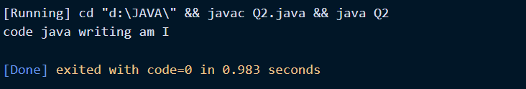

NOTE: I have not use extended class to solve and relate the Q but the code used in solving the Q is similar to what used in previous Q.

Explanation:

* It was asked to display the value of each node in reverse order(without reversing the Linked List itself) means the linked list will remain same but the values that are being hold by node will reverse.
* We created a tempNode which will store our node data temporarily and after fulfilling all conditions the tempNode will print the values present inside it.

3. Write a java code to reverse the order of singly linked list and display the value in each node (use the linked list used in Q1).

CODE:

*public* *class* Q3 {

*static* Node head; // *head of list*

*static* *class* Node {

        String data;

        Node next;

*Node*(String string)

        {

            data = string;

            next = null;

        }

    }

*static* Node *reverse*(Node head)

    {

*if* (head == null || head.*next* == null)

*return* head;

        /\* *reverse the rest list and put*

*the first element at the end* \*/

        Node rest = *reverse*(head.*next*);

        head.*next*.*next* = head;

        head.*next* = null;

        /\* *head is null now and rest of list is returned* \*/

*return* rest;

    }

    /\* *Function to print linked list* \*/

*static* void *print*()

    {

        Node temp = head;

*while* (temp != null) {

            System.*out*.*print*(temp.*data* + " ");

            temp = temp.*next*;

        }

        System.*out*.*println*();

    }

     //*end of static class node*

        //*main method*

*public* *static* void *main*(String[] args) {

    Q3 LList = *new* *Q3*(); // *create an empty Linked list*

    // *create 5 nodes*

    LList.*head* = *new* *Node*("I");

    Node two = *new* *Node*("am");

    Node three = *new* *Node*("writing");

    Node four = *new* *Node*("java");

    Node five = *new* *Node*("code");

    //*five nodes allocated dynamically*

    //*link first 'head' node with node 'two'*

    LList.*head*.*next* = two;

    //*link node 'two' to node 'three'*

    two.*next* = three;

    //*link node 'three' to node 'four'*

    three.*next* = four;

    //*link node 'four' to node 'five'*

    four.*next* = five;

    System.*out*.*println*("Initial linked list:");

*print*();

    head = *reverse*(head);

    System.*out*.*println*("Linked list after reversing:");

*print*();

    }//*end of main method*

    } //*end of class Q3*

OUTPUT:

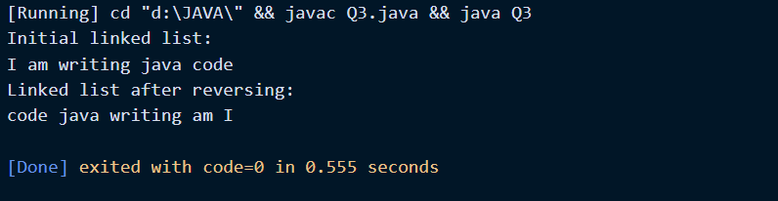

NOTE: I have not use extended class to solve and relate the Q but the code used in solving the Q is similar to what used in previous Q.

Explanation:

* We have divided linked list into two parts i.e., first node and rest of nodes. Here, we will reverse the rest of nodes and link it to the first node.
* Finally, we will fix the head pointer and will display the code.

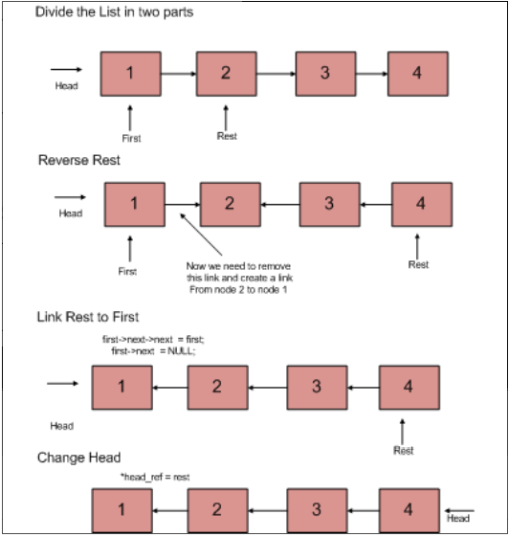

4. Use the linked list in Q1. Write a java code to replace the word ‘writing’ with ‘scribbling’ and display the value in each node.

CODE:

*public* *class* Q4 {

    Node head; // *'head' of the linked list*

    // *node in the Linked list is a class*

*static* *class* Node{

    String data;

    Node next;

    //*constructor is used to create a new Node and Next is by default is initialized as null*

*Node*(String string){

          data = string;

          next = null;

    } //*end of constructor*

    } //*end of static class node*

*public* void *DisplayList*(){

        // *Start from head*

        Node node = head;

        /\* *While loop to traverse through the linked list.*

*It will stop execution once the node is null.*

\*/

*while*(node!=null){

        // *node.data is used to access the data inside node*

        System.*out*.*print*(node.*data* + " ");

        // *proceed to next node*

        node = node.*next*;

        }

        }

    // *replace writing with scribbling*

void *replaceWord*(String oldWord, String newWord){

    Node node = head;

    /\* *While loop to iterate through linked list to check if old word is string in linkedlist. \*/*

*while* (node != null){

*if*(node.*data*.*equals*(oldWord)){

    node.*data* = newWord;

    }

    node = node.*next*;

    }

}

    //*main method*

*public* *static* void *main*(String[] args) {

    Q4 LList = *new* *Q4*(); // *create an empty Linked list*

    // *create 5 nodes*

    LList.*head* = *new* *Node*("I");

    Node two = *new* *Node*("am");

    Node three = *new* *Node*("writing");

    Node four = *new* *Node*("java");

    Node five = *new* *Node*("code");

    //*five nodes allocated dynamically*

    //*link first 'head' node with node 'two'*

    LList.*head*.*next* = two;

    //*link node 'two' to node 'three'*

    two.*next* = three;

    //*link node 'three' to node 'four'*

    three.*next* = four;

    //*link node 'four' to node 'five'*

    four.*next* = five;

    // *Call replaceWord method*

    LList.*replaceWord*("writing", "scribbling");

    // *display value at each node*

    LList.*DisplayList*(); // *Traverse the list*

    }//*end of main method*

    } //*end of class Q4*

OUTPUT:

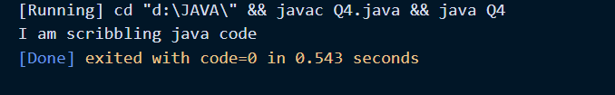

NOTE: I have not use extended class to solve and relate the Q but the code used in solving the Q is similar to what used in previous Q’s.

Explanation:

* A method named replaceWord is created which will take two strings as input, one string will take old word and other string take the new word.
* A while loop is created to traverse through linked list and an if condition is used to check whether the old word is present in linked list and if this condition follows old word gets replaced with new word.
* In ‘Main’ class we will use replaceWord method to give old string and new string and will finally display the OUTPUT.

5. Write a java code to check whether the parentheses are balanced in the given expression “ [[]{}]((){[]} ” . Parentheses are balanced if there is a closing bracket corresponding to an opened one. Implement with Stack.

CODE:

*public* *class* Q5 {

    // *The stack is created using arrays*

*public* char [] array;

*public* int top;

*public* *static* int length;

    // *Constructor to create stack of dimension provided as argument.*

*Q5*(int dim){

    array = *new* char[dim];

    length = dim;

    // *Top is maintained, the default value is -1 (no elements)*

    top = -1;

    }

    // *Method for pushing element to Stack*

*public* void *push*(char data){

    // *Check if Stack is full. If yes, exit*

*if*(*isFull*()){

    System.*out*.*println*("Stack Full");

    System.*exit*(1);

    }

    // *Increment the Stack pointer*

    top = top+1;

    array[top] = data;

    }

    // *Method to pop element from Stack*

*public* char *pop*(){

    // *Check if stack is empty. If yes, exit.*

*if*(*isEmpty*()){

    System.*out*.*println*("Stack Empty");

    System.*exit*(1);

    }

    // *Decrement the stack pointer*

    top = top - 1;

    // *Return the popped value*

*return* array[top+1];

    }

    // *Method to check if the Stack is full*

*public* boolean *isFull*(){

    /\* *If Stack Pointer is = length -1 then the Stack is full*

*and this method will return true.* \*/

*return* top==(length-1);

    }

    // *Method to check if the Stack is full*

*public* boolean *isEmpty*(){

    // *If Stack Pointer is -1, the Stack is empty.*

*return* top==-1;

    }

    // *Method to print the values in Stack*

*public* void *print*(){

    // *Same as traversing an array*

*for*(int i = 0; i < top; i++){

    System.*out*.*println*(array[i]);

    }

}

*public* *static* boolean *balancedParenthesis*(String str) {

        Q5 stack = *new* *Q5*(str.*length*());

*for* (int i = 0; i < str.*length*(); i++) {

            char x = str.*charAt*(i);

*if* (x == '(' || x == '[' || x == '{') {

                stack.*push*(x);

*continue*;

            }

*if* (stack.*isEmpty*())

*return* false;

// *To store the char value that's stored in the stack*

            char fromStack;

// *Switch case to check*

*switch* (x) {

/\*

*The program is checking if the stack contains a right parenthesis.*

*If the right parenthesis is not the matching one, it will return*

*false.*

*If the current char is ')' and the value popped from stack is '{'*

*When you combine them it will be '{)'*

\*/

*case* ')' -> {

             fromStack = stack.*pop*();

*if* (fromStack == '{' || fromStack == '[')

*return* false;

}

*case* '}' -> {

            fromStack = stack.*pop*();

*if* (fromStack == '(' || fromStack == '[')

*return* false;

}

*case* ']' -> {

            fromStack = stack.*pop*();

*if* (fromStack == '(' || fromStack == '{')

*return* false;

}

}

}

// *If the traversal is complete and there's still some string remaining, then strings are unbalanced*

*return* (stack.*isEmpty*());

}

*public*

*static* void *main*(String[] args) {

        String str = "[[]{}]((){[]}";

*if* (*balancedParenthesis*(str))

            System.*out*.*println*("Balanced");

*else*

            System.*out*.*println*("Unbalanced");

    }

}

OUTPUT:

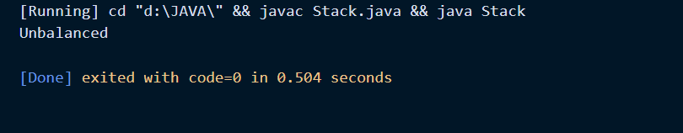

Explanation:

* Initially a stack is being created using array where method for push, pop and Boolean isfull() are written.
* Another method is created to check whether parentheses are balanced or not. Initially in the method parentheses are pushed into stack.
* The switch statement is used to perform different actions based on different conditions. In switch statement it is checked whether right parentheses is closed with correct left parentheses. If not, then return false and hence, parentheses are said to be unbalanced.
* Refer diagram below for easy understanding:-

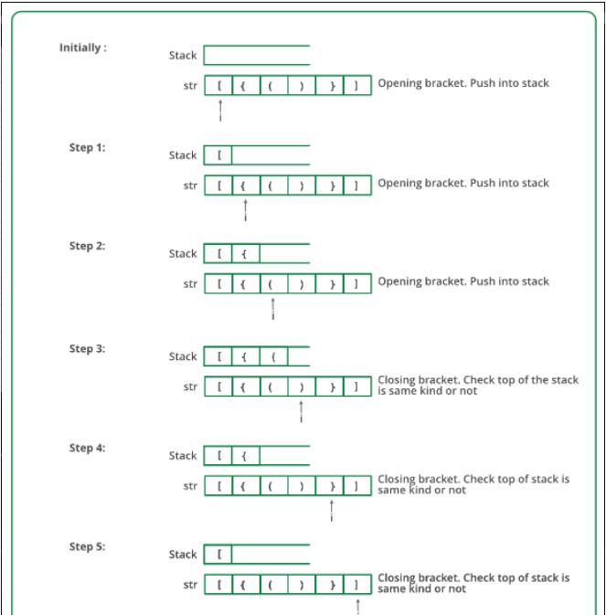

THANK YOU